CPE301 – SPRING 2019

Design Assignment DA1B

Student Name: Gabriela Cuicas

Student #: 5002960022

Student Email: cuicas@unlv.nevada.edu

Primary Github address: https://github.com/cuicattack/cat1

Directory: https://github.com/cuicattack/cat1/Cat1Assn2

1. **DEVELOPED CODE OF TASK 1**

Task 1 stated to:

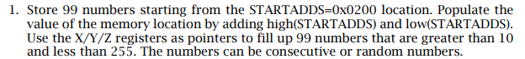

To perform the operation, I started by defining the memory location of my x register to be 0x0200. I initialized a register to 10 and made a loop that would increment that register and continue to store the value into the next space in register x.





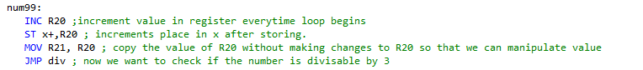

1. **DEVELOPED CODE OF TASK 2**

The second task asked to:



To perform this operation, I made a loop that continuously subtracted a number by 3 until the number was less than three. Every time a new number was generated and stored in x it would check to see if the number was divisible by 3. From there is would check to see if the remainder was 0 or a number to branch to the next areas. If the remainder was 0 it would store the original unmodified number of x into an array of y. Otherwise, it would store that value into the z registers.

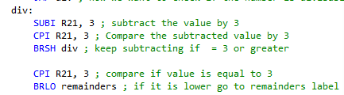

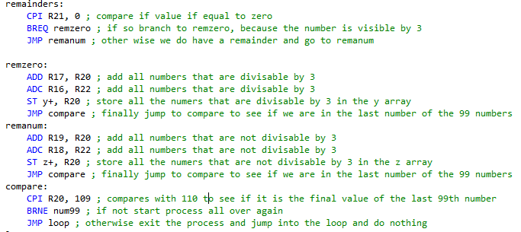

1. **DEVELOPED CODE OF TASK 3**

The third task asked to:



To perform this operation, the addition would happen after the check if the number was or wasn’t divisible by 3. I knew the generated number in R20 would never be more than 255 so all I had to do was keep adding R20 with the low byte of my sum, R17. Then if I had a carry I would add that to R16, my high byte. The same logic follows for the addition of R19 and R18.

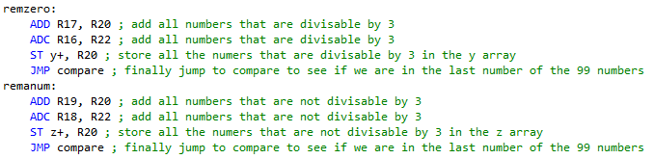

1. **CCOMPLETE CODE**

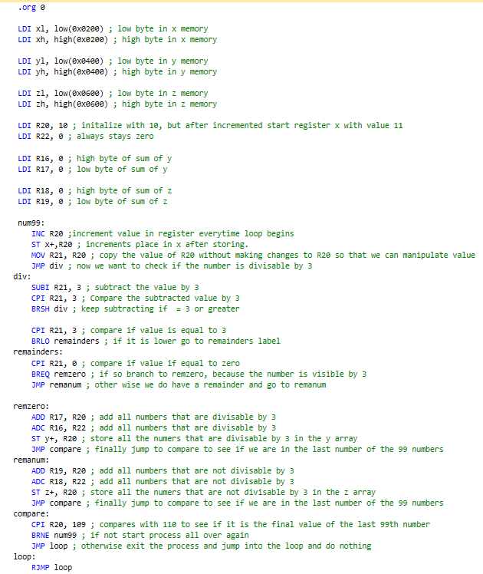

1. **SCREENSHOTS OF EACH TASK OUTPUT**

99 numbers stored in x:

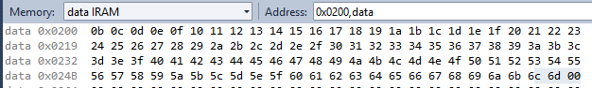

Numbers divisible by 3 stored in y:



Numbers not divisible by 3stored in z:

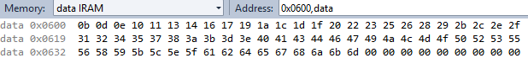

Values of sum stored in registers:

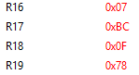

Sum of numbers divisible by 3 = 07BC = 1980 in decimal

Sum of numbers not divisible by 3 = 0F78 = 3960 in decimal

Time code takes to run

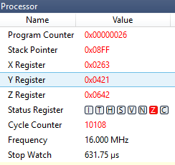

1. **VERIFICATION IN PYTHON**

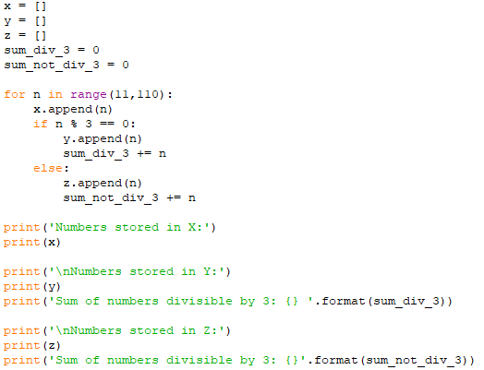

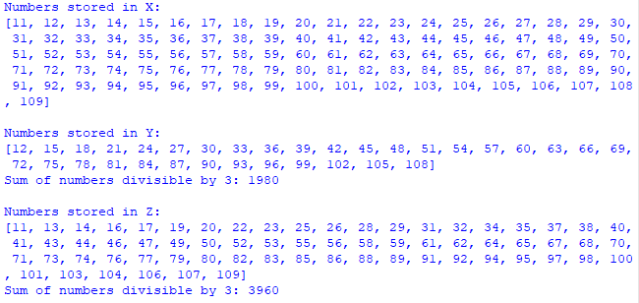

1. **GITHUB LINK OF THIS DA**

**Student Academic Misconduct Policy**

<http://studentconduct.unlv.edu/misconduct/policy.html>

“This assignment submission is my own, original work”.

NAME OF THE STUDENT